**SQL Script for Monthly Sales Trend Analysis**

**SQL-Script: -**

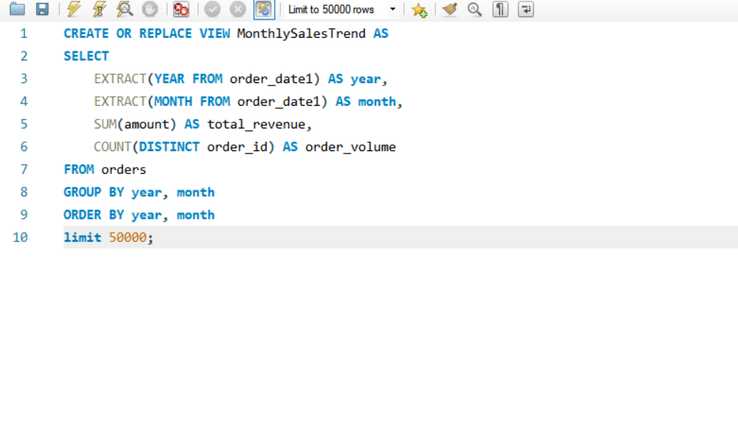

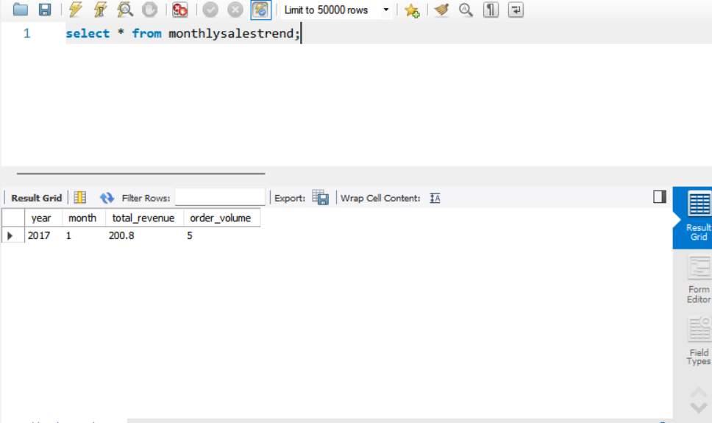

Clear information in Readme